Neural Network Machines
Howard C. Anderson
Published in February 1989 issue of “IEEE Potentials”

The Von Neumann machine architecture, remarkably successful at handling many problems, is now viewed by many to be limited. Von Neumann machines can do things, such as compute missile trajectories, that humans have great difficulty doing. But, we can do things, such as take dictation, that we have great difficulty making Von Neumann machines do.
Thus, neural network machine architectures are currently under intensive investigation. These new architectures are based on knowledge about “biological computers” such as the human brain. At present, most researchers are using simulation on Von Neumann machines to investigate alternative neural network machine architectures. Some neural network machines, however, have already been manufactured as experimental silicon chips.
A Von Neumann machine typically has a very complex instruction-processing unit that sequentially accesses a memory bank to perform a sequence of instructions. A neural network machine is a very complex network of very simple processing units that operate asynchronously but in parallel. Von Neumann machines evolved primarily from A. M. Turing’s theoretical work on David Hilbert’s 23rd problem. Neural network machines are evolving primarily from practical studies of neurobiological structures.
The dream of making a “thinking machine” is the driving force for investigating alternative machine architectures based on neurophysiological models. It is also the driving force for the field of study known as artificial intelligence.

Back then
The thinking in the late sixties was that “artificial intelligence” could be achieved on Von Neumann machines, and that there was no practical reason to pursue investigation of alternative machine architectures. In fact, the artificial intelligence community effectively closed the door on research in this area for nearly 20 years when Minsky and Papert published their book “Perceptrons.” The book analyzed the limitations of what is now recognized as one of the most elementary and limited forms of neural network machine architectures.
In addition, the mainstream artificial intelligence community paid little attention to alternative machine architectures. We presume this is because Turing had shown that a digital computer is a “universal machine” capable of simulating any other digital or analog computer and can “... carry out any task that is explicitly described.” Turing also wrote, “... considerations of speed apart, it is unnecessary to design various new machines to do various computing processes. They can all be done with one digital computer, suitably programmed for each case.” Clearly then, the “universal machine” is sufficient for all processes which can be explicitly described and for which processing time is immaterial.
Unfortunately, many of the processes we wish our machines to perform must be done in a timely, efficient manner. Also, we have been unable to “explicitly describe” many of the processes we want our machines to perform. (Even though some of the best minds have been working on such problems for years.) Processes that for us are relatively simple and accomplished quickly, e.g., recognizing a face in a photograph or taking dictation, seem to be incredibly difficult for the “universal machine.”

Our role model
There is only one known model of a “thinking machine” and that is the human brain. So far we don’t know how it operates overall but we are beginning to think we understand how small pieces of it work. A simplified view is that it appears to be a complex network of communication lines (axons and dendrites) linking small processing units (neurons) together. The communication lines transfer electrical signals to the processing units via small resistors (synaptic junctions). Memory in the brain appears to consist primarily of the values assigned to the resistors once the topology is established. The processing units receive signals from many other processing units, add the values, and then produce a somewhat proportional but “amplitude” limited output signal if the summed values exceed a “thresh old” value. The output signal is then transmitted across the communication lines to other resistors connected to other processing units. The process of learning seems to be primarily a matter of changing the values of the resistors. (There are “inhibitory” and “excitatory” neurons, so the simplified electronic analogy referred to here must be biased in some way.)
“Amplitude” in a biological network refers to the rate at which a neuron fires. In a simulated neural network, the amplitude can be represented by a real number. In a silicon implementation, the amplitude can be represented by a voltage or a current.
Amplitude limiting in a simulation can be performed by applying a sigmoid function, an “S” shaped curve that asymptotically approaches a maximum positive output value for large positive sums and asymptotically approaches a maximum negative output value for large negative sums. The sigmoid function seems to simulate reasonably well the observed behavior of real biological neurons.

Two ways to remember
There are two basic types of memory supported by neural network machines, auto-associative memory and associative memory. An auto-associative memory stores patterns. Patterns are retrieved by stimulating the machine with a partial or a degraded pattern sometimes referred to as a “key.” The machine responds by reconstructing the original pattern from the key. In a neural network machine, the patterns are stored as modifications of synaptic weights rather than as identifiable segments as would be done on a Von Neumann machine. The patterns in a neural network machine are stored throughout the machine’s “memory” so that all patterns coexist in a holographic manner. There is no pattern search operation that is performed in order to retrieve a pattern. Instead, the key is used as a source of starting values for the input neurons. The network then converges to the closest pattern by interactively adjusting the activity values of the other neurons until they settle at the appropriate “state” for that pattern. These operations are done in parallel and the operations performed are identical regardless of the stimulus pattern or key.
An associative memory is similar to an auto-associative memory except that it stores pairs of patterns that are associated with each other. An example would be the graphical pattern of the letter “ A “ and its ASCII code, Hex 41. If these were stored in an associative memory, presentation of the graphical “ A “ would stimulate the machine to respond with the ASCII “ A,” Hex 41. Again the operation does not involve a search operation. Instead, neuron activity values adjust themselves and converge in a “stimulus-response” way to generate the correct pattern association.
An associative memory neural network machine is essentially a non-linear vector operator that transforms a set of real vectors into another set of real vectors. Learning algorithms are used to adjust the resistors in the neural network machine so that it learns to transform a given set of input vectors into a given set of corresponding output vectors. The most natural way to program a neural network machine is to present examples to it. Neural network machines are able to learn by example.
At present many researchers are experimenting with all sorts of learning algorithms via simulation on digital processors. Some of these learning algorithms appear to be consistent with what is known of the brain and some appear to be inconsistent. As a result, there are two schools of thought currently with respect to neural network machine design. Some believe we should follow the biological model closely, and others believe departure from the biological model will still achieve the same end. It should be noted that the serial digital processor represents one of the possible departures from the biological model. However, it is not clear where other possible departures will lead. On the other hand, biological models are not complete at present so it is difficult to tell where work strongly influenced by them will lead. We hope neurophysiology and neural network machine research are “convergent technologies” that will be able to contribute to each other thus accelerating the progress in each field. Meanwhile, understanding just what it is that neural network machines do, and why they exhibit such interesting and powerful capabilities is of paramount importance.

Associative recall
The power inherent in associative memory neural network machines appears to stem primarily from their ability to perform non-linear vector transformations. The “exclusive-or” or XOR function in electronics can be stated as a vector transformation problem. The problem is to find a transformation operator “T” that transforms a set of “x” vectors into a set of “y” vectors as shown in the following table:
“x” “y”
(0,0) -> (0)
(1,0) -> (1)
(0,1) -> (1)
(1,1) -> (0)

We can rewrite these relationships as:
(0,0)T = (0)
(1,0)T = (1)
(0,1)T = (1)
(1,I)T = (0) (1)

Now the definition of a linear transformation, T, over the set of real numbers is the following:
Let V and U be vector spaces over the set of real numbers. Let T:V -> U satisfy

(1) (v1 + v2)T = (v1)T + (v2)T, for all v1, v2 within V, and
- (av)T = a(vT), for all real numbers “a “, and for all v within V,

then T is a linear transformation from V to U.

So let’s test T given in the set of equations (1) to see if T could be a linear transformation. Applying the first condition of the definition of a linear transformation to the second and third of equations (1), we must have:
[(0,1) + (1,0)]T = (0,1)T + (1,0)T,
or (1,1)T = (0,1)T + (1,0)T,
or (0) = (1) + (1),
or (0) = (2),
which is not true, therefore, T cannot be a linear transformation!
It is somehow surprising that the simple exclusive-or function, so important and fundamental to digital processing, involves a non-linear operator. It is also surprising, in view of this fact, that our mathematics texts say so much about linear transformations and so little about non-linear transformations. A neural network machine to perform the XOR function is shown in figure 1.
The green triangles represent “neurons” and the red circles represent “synapses.” Each of the neurons in the example has a “threshold” value of .01; i.e., the neuron fires only if the sum of its input values multiplied by their respective synapse coefficients exceeds .01. There are two “input neurons,” neurons one and two with values of one or zero representing the true or false values of logical variables” A “ and “B.” There are two more neurons, neurons three and four which each have two synapses that are connected to the input neurons. The values of the synapses are as shown in figure 1. Let the symbol “~” denote “NOT” and let ”^“ denote “EXCLUSIVE OR.” Note that the synapse values of neurons three and four have been chosen so that neuron three produces (~ A)(B) and neuron four produces (A)(~B). The fifth neuron is an “output neuron” with two synapses that receive input from neurons three and four. The values of its synapses are as shown in figure 1. The output “C” of the output neuron is the “exclusive or” of A and B. (Recall that (~A)(B) + (A)(~B) = A ^ B.) For example, if “A” is 1 and “B” is 0 then neuron three’s output will be 0 (since the sum of the weighted input values is -1 and that is below the threshold value of .01). Neuron four’s output will be + 1 and neuron five’s output will then be the sum of +1 and 0 or +1. If however “A” is 1 and “B” is 1 then neuron three’s internal sum will be 0, its output will be 0, neuron four’s internal sum will be 0, its output will be 0 and neuron five’s output will then be the sum of 0 and 0 or zero.

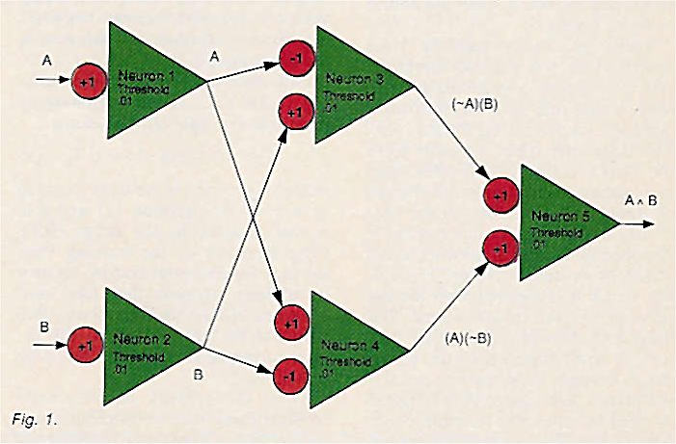
Note that the two neurons on the left are called input neurons because they are connected directly to “real world” input signals. The neuron on the right is called an output neuron since it provides an output to the “real world.” The two neurons in the middle are called “hidden units.” Hidden units must be present in order to perform the XOR function. They are the source of the non-linearity that allows the network to perform as a non-linear vector operator.

Auto-associative recall
Now let’s describe mathematically the relatively simple neural network model shown in figure 2, a one layer, fully connected neural network that behaves as an auto-associative memory.
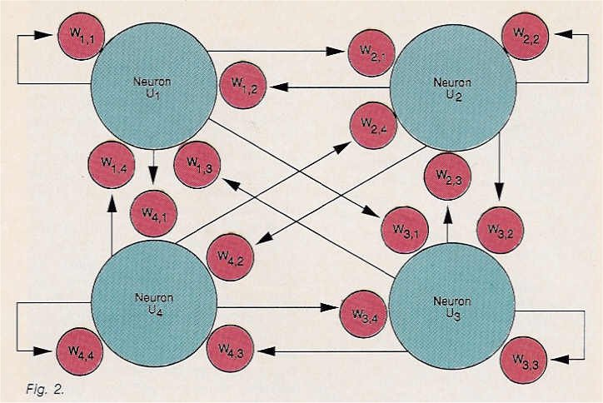
We will be using the term “activation rules.” Activation rules refer to the mathematical formulae that determine the current value or “activation value” of a particular neuron.
Assume we have N neurons, u_{i}, whose activity values at time “t” are a_{i}(t). Assume that each neuron, u, has a set of input or synaptic weights, W_{ij}, so that the output of some neuron, a_{i}, is first multiplied by the weight W_{ij} before being given to neuron u_{i}. Assume that the set of weighted values provided to neuron u_{i} are added together and then amplitude limited by a sigmoid function and that this result then becomes the new activity value, a_{i}( t+ 1 ), of neuron u_{i} at time “t+l”. Then we have described a one layer, fully connected neural network.
The activity value a_{i} at time “t” of neuron u_{i} is given by:
$a_{j}(t)=σ(\sum_{j=1}^{N}{W_{\text{ij}}}a_{j}(t−1))$ (2)
where $σ$ is the sigmoid function. The sigmoid function is often chosen to be
$σ(x)=x/(1+|x|)$ where x is a real number.
Note that we could have chosen a more complicated function in place of the summation of the products of the W_{ij} and the a_{j}. Also some other function could have been chosen for the sigmoid. Many different models of neural networks using different functions exist within the current literature. The model just described is a particularly simple one.
Now we may select some of these neurons to be input neurons and assign their values from “real-world” sources or terminals rather than let the equations set their values. Similarly, we may select specific neurons to be output neurons and pass their output values to “real-world” output terminals. Note that the W_{ij} values contain all of the “knowledge” embedded in the network. “Learning rules” refer to the mathematical formulae, which determine how the W_{ij} values are modified when the neural network learns.
There are many learning rules described in the current literature. We will choose a particularly simple learning rule here for illustrative purposes known as the “delta rule.” The delta rule takes its name from the Greek delta symbol often used in mathematics to signify the amount of change of a variable. In the case of neural networks, an input vector is provided to the neural network and it produces an output vector. The output vector is compared with the desired or correct output vector. The difference between these two vectors, or some function of the difference between these two vectors, is the “delta” referred to. This delta can be used as input to a function which adjusts the W_{ij} so that the difference between the output vector and the desired output vector will be reduced. The equations for the delta rule are:
${ΔW}_{\text{ij}}(t)=η(T_{i}−a_{i}(t−1))a_{j}(t−1)$ for all i and j (3)
and
$W_{\text{ij}}(t)=W_{\text{ij}}(t−1)+{ΔW}_{\text{ij}}(t)$ for all i and j (4)
where $η$ is the learning rate, a real number that is usually in the range [0,1], and “T” is a training or target vector which the machine is trying to learn.
Now, depending upon the learning rate, $η$, it may take several iterations of the above equations (3 and 4) before the network “learns” the vector “T.” A training interval refers to one of the time steps from time “t -1” to time “t” during which the training vector is injected into the network, the W_{ij} are adjusted, and the new a_{i} are computed.
Note that we may inject the training vector, “T”, at the beginning of each training interval, by setting
$a_{i}'(t−1)=a_{i}(t−1)+{ρT}_{i}$ (5)
where $a_{i}'(t−1)$ is to be used in place of $a_{i}(t−1)$ in equation (3) and $ρ$ is a real number in the range [0,1]. (The injection of the training vector may be accomplished by sensory or dummy neurons that feed into synapses of the “real” neurons.) The response of the network to the injected training vector is computed by equation (2).
Once the network has “learned” to distinguish several different training vectors, we may turn learning off by not performing equations (3) and (4). Injecting part or all of a pattern will then cause the machine, via equations (2) and (5), to attempt to reproduce the nearest training vector. The results are the a_{i} values produced by equation (2). This type of machine is most similar to the “auto-associative” kind.
The interest in neural network machines is growing rapidly at this point. Neural network machines appear to be required to solve some of the most pressing problems in artificial intelligence. These machines will not replace Von Neumann machines but will probably be introduced as hybrids. There is plenty of work ahead, however, before the dream is achieved. Work is needed in non-linear mathematics, chip design (there is a three-dimensional interconnect problem that will need to be solved), and neurophysiology, to name a few. These machines will be an important part of future computing systems.

Read more about it
- Hopcroft, John E., “Turing Machines.” Scientific American, May 1984, p. 86.
- Rumelhart, D. E., and McClelland, J. L. (Eds.), Parallel Distributed Processing. MIT Press, 1986, p. 110,111.
- Hubert L. Dreyfus, What Computers Can’t Do. Harper & Row, New York, 1972, p. xx.

About the author
Howard C. Anderson is a member of Motorola’s technical staff, and a member of their Neural Network Development Group.

